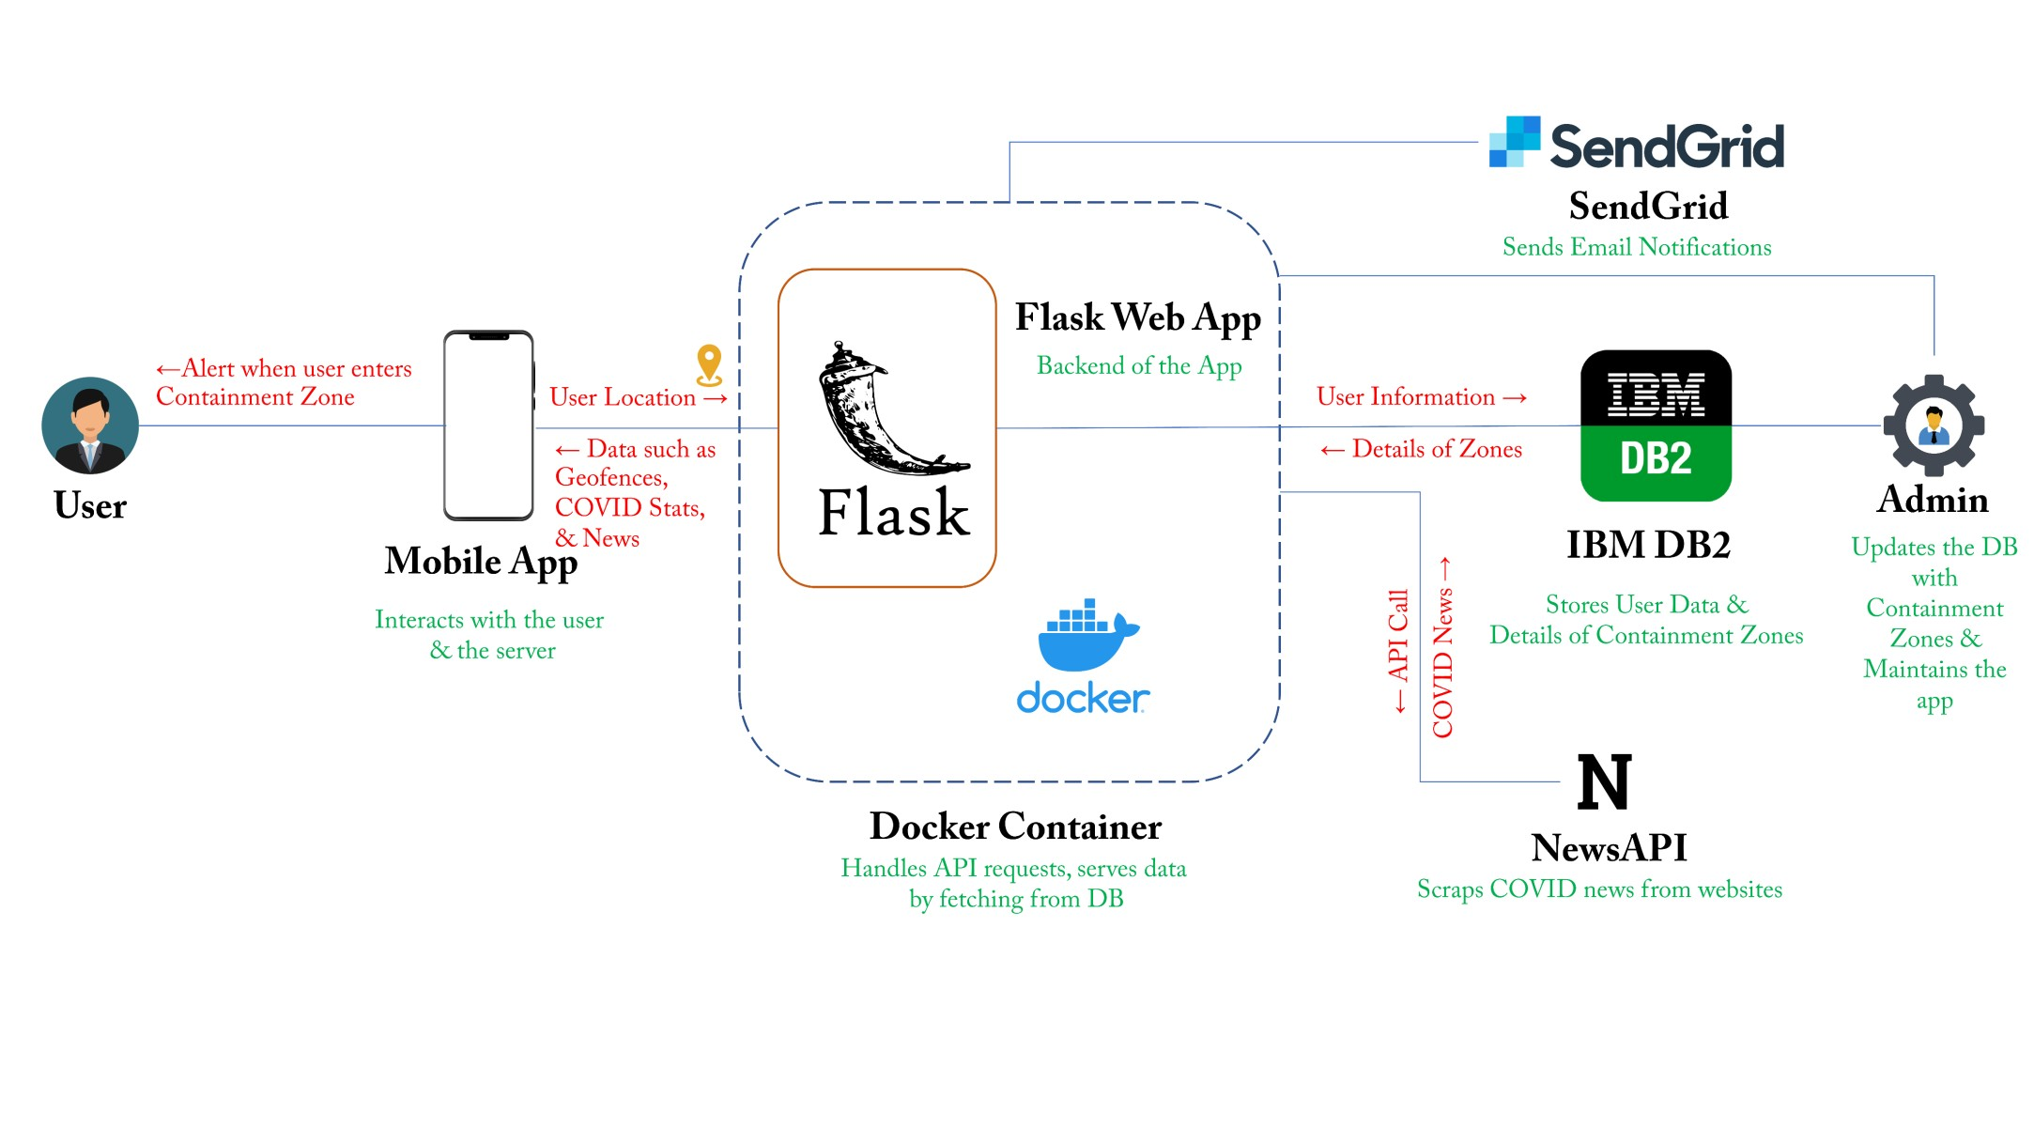Containment Zone Alerting Application Project Design Phase II -Technical Architecture Team ID: PNT2022TMID12468